
Please change the last digit to 8534
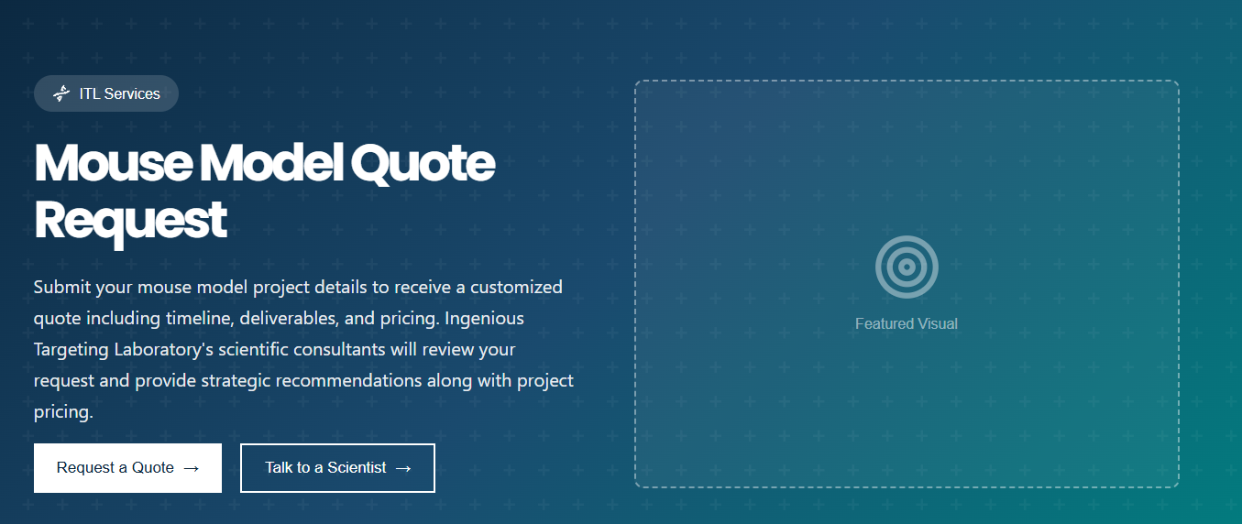
Request a quote does not go anywhere, ITL services should be changed to ingenious targeting laboratory and no featured visual

Custom model quote does not connect to quote page

Schedule a meeting should be connected to Hubspot calendar

